BIPM
# Source: AI Source: Provided by: [Data Path: Persons Table -> ID Column: 1, Name_En Column: Motasem Essam] -> From: [ChatGPT] on [7/17/2026]
The International Bureau of Weights and Measures (BIPM) is an international intergovernmental organization responsible for ensuring the worldwide uniformity of measurements and coordinating the International System of Units (SI). It works with national metrology institutes and international organizations to maintain globally accepted measurement standards and promote measurement traceability.
The BIPM is the central organization responsible for international measurement coordination and plays a vital role in science, industry, commerce, healthcare, and technology.

Definition
# Source: AI Source: Provided by: [Data Path: Persons Table -> ID Column: 1, Name_En Column: Motasem Essam] -> From: [ChatGPT] on [7/17/2026]
The International Bureau of Weights and Measures (BIPM) is an international organization established by the Metre Convention (Convention du Mètre) to coordinate and maintain the global system of measurement.
It provides the international framework that allows measurements made in different countries to be accurate, consistent, and comparable.

Full Name
# Source: AI Source: Provided by: [Data Path: Persons Table -> ID Column: 1, Name_En Column: Motasem Essam] -> From: [ChatGPT] on [7/17/2026]
English
International Bureau of Weights and Measures
French (Official Name)
Bureau International des Poids et Mesures
Abbreviation
$$\boxed{\text{BIPM}}$$

Establishment
# Source: AI Source: Provided by: [Data Path: Persons Table -> ID Column: 1, Name_En Column: Motasem Essam] -> From: [ChatGPT] on [7/17/2026]
- Established: 1875
- Established by: The Metre Convention
- Headquarters: Sèvres, France
- Type: International intergovernmental organization

Mission
# Source: AI Source: Provided by: [Data Path: Persons Table -> ID Column: 1, Name_En Column: Motasem Essam] -> From: [ChatGPT] on [7/17/2026]
The BIPM's mission is to:
- Ensure worldwide uniformity of measurements.
- Coordinate the International System of Units (SI).
- Promote measurement traceability.
- Support scientific and technological progress.
- Facilitate international trade.
- Improve measurement accuracy worldwide.

Objectives
# Source: AI Source: Provided by: [Data Path: Persons Table -> ID Column: 1, Name_En Column: Motasem Essam] -> From: [ChatGPT] on [7/17/2026]
The BIPM aims to:
- Maintain the international measurement system.
- Support international comparisons of national standards.
- Coordinate global metrology activities.
- Improve measurement reliability.
- Encourage international cooperation in measurement science.

Main Responsibilities
# Source: AI Source: Provided by: [Data Path: Persons Table -> ID Column: 1, Name_En Column: Motasem Essam] -> From: [ChatGPT] on [7/17/2026]
The BIPM is responsible for:
- Coordinating the International System of Units (SI).
- Organizing international comparisons between national metrology institutes.
- Maintaining international reference standards where appropriate.
- Supporting scientific metrology.
- Publishing official SI documentation.
- Promoting global measurement traceability.
- Providing technical expertise to member states.

Role in the International System of Units (SI)
# Source: AI Source: Provided by: [Data Path: Persons Table -> ID Column: 1, Name_En Column: Motasem Essam] -> From: [ChatGPT] on [7/17/2026]
The BIPM is responsible for coordinating the worldwide implementation of the SI system.
It helps ensure that:
- SI units are interpreted consistently.
- National standards remain traceable.
- Measurement results are comparable worldwide.

Relationship with Other Organizations
# Source: AI Source: Provided by: [Data Path: Persons Table -> ID Column: 1, Name_En Column: Motasem Essam] -> From: [ChatGPT] on [7/17/2026]
The BIPM works closely with several international organizations.
General Conference on Weights and Measures (CGPM)
The CGPM is the highest authority governing the International System of Units.
It:
- Adopts SI definitions.
- Approves major decisions.
- Oversees the work of the BIPM.

International Committee for Weights and Measures (CIPM)
# Source: AI Source: Provided by: [Data Path: Persons Table -> ID Column: 1, Name_En Column: Motasem Essam] -> From: [ChatGPT] on [7/17/2026]
The CIPM supervises the scientific work of the BIPM.
It:
- Directs technical activities.
- Advises the CGPM.
- Coordinates international metrology programs.

National Metrology Institutes (NMIs)
# Source: AI Source: Provided by: [Data Path: Persons Table -> ID Column: 1, Name_En Column: Motasem Essam] -> From: [ChatGPT] on [7/17/2026]
Examples include:
- National Institute of Standards and Technology (NIST) – United States
- National Physical Laboratory (NPL) – United Kingdom
- Physikalisch-Technische Bundesanstalt (PTB) – Germany
- National Metrology Institute of Japan (NMIJ)
The BIPM works with these organizations to ensure worldwide measurement consistency.

Areas of Work
# Source: AI Source: Provided by: [Data Path: Persons Table -> ID Column: 1, Name_En Column: Motasem Essam] -> From: [ChatGPT] on [7/17/2026]
The BIPM supports measurements involving:
- Length
- Mass
- Time and frequency
- Electric current
- Temperature
- Amount of substance
- Luminous intensity
- Ionizing radiation
- Chemistry
- Acoustics
- Photometry
- Gravimetry

International Comparisons
# Source: AI Source: Provided by: [Data Path: Persons Table -> ID Column: 1, Name_En Column: Motasem Essam] -> From: [ChatGPT] on [7/17/2026]
One of the BIPM's major responsibilities is organizing international comparisons.
These comparisons:
- Verify national standards.
- Improve measurement consistency.
- Establish global traceability.
- Support laboratory accreditation.

Measurement Traceability
# Source: AI Source: Provided by: [Data Path: Persons Table -> ID Column: 1, Name_En Column: Motasem Essam] -> From: [ChatGPT] on [7/17/2026]
The BIPM helps maintain global traceability.
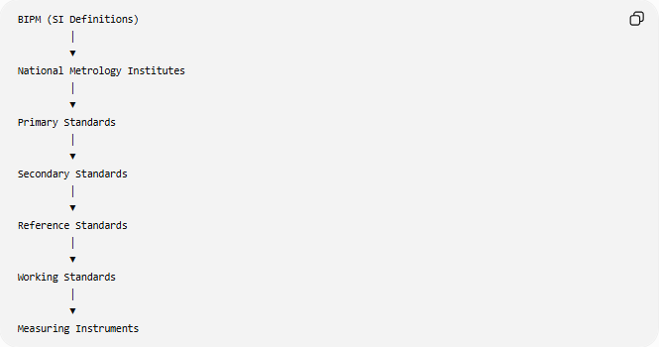
BIPM (SI Definitions)
│
▼
National Metrology Institutes
│
▼
Primary Standards
│
▼
Secondary Standards
│
▼
Reference Standards
│
▼
Working Standards
│
▼
Measuring Instruments

Member States
# Source: AI Source: Provided by: [Data Path: Persons Table -> ID Column: 1, Name_En Column: Motasem Essam] -> From: [ChatGPT] on [7/17/2026]
The BIPM is supported by dozens of Member States and many Associate States and Economies, representing most of the world's industrialized and developing nations.
Member participation ensures international cooperation in measurement science.

Publications
# Source: AI Source: Provided by: [Data Path: Persons Table -> ID Column: 1, Name_En Column: Motasem Essam] -> From: [ChatGPT] on [7/17/2026]
The BIPM publishes important international documents, including:
- The SI Brochure (official description of the International System of Units).
- Guides on measurement traceability.
- International comparison reports.
- Technical recommendations.
- Metrology reference documents.

Applications
# Source: AI Source: Provided by: [Data Path: Persons Table -> ID Column: 1, Name_En Column: Motasem Essam] -> From: [ChatGPT] on [7/17/2026]
The work of the BIPM supports:
- Scientific research
- Manufacturing
- Engineering
- Medicine
- Aerospace
- Telecommunications
- Navigation
- International trade
- Calibration laboratories
- Environmental monitoring

Everyday Importance
# Source: AI Source: Provided by: [Data Path: Persons Table -> ID Column: 1, Name_En Column: Motasem Essam] -> From: [ChatGPT] on [7/17/2026]
Although most people never interact directly with the BIPM, its work helps ensure:
- Accurate grocery scales.
- Reliable medical equipment.
- Correct fuel pump measurements.
- Consistent GPS positioning.
- Fair international trade.
- Accurate laboratory testing.
- Precision manufacturing.

Common Mistakes
# Source: AI Source: Provided by: [Data Path: Persons Table -> ID Column: 1, Name_En Column: Motasem Essam] -> From: [ChatGPT] on [7/17/2026]
- Confusing the BIPM with the SI system. (The BIPM coordinates and maintains the SI system; it is not the SI system itself.)
- Confusing the BIPM with national metrology institutes.
- Assuming the BIPM performs routine instrument calibration for industry.

Key Points
# Source: AI Source: Provided by: [Data Path: Persons Table -> ID Column: 1, Name_En Column: Motasem Essam] -> From: [ChatGPT] on [7/17/2026]
- BIPM stands for International Bureau of Weights and Measures.
- It was established in 1875 by the Metre Convention.
- Its headquarters are in Sèvres, France.
- It coordinates the International System of Units (SI).
- It works with national metrology institutes worldwide.
- It ensures global measurement consistency and traceability.

BIPM vs. CGPM
# Source: AI Source: Provided by: [Data Path: Persons Table -> ID Column: 1, Name_En Column: Motasem Essam] -> From: [ChatGPT] on [7/17/2026]
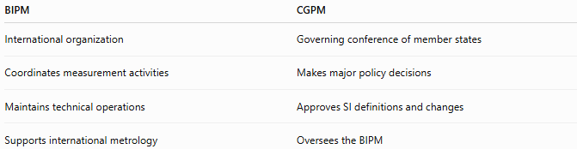
BIPM | CGPM
International organization | Governing conference of member states
Coordinates measurement activities | Makes major policy decisions
Maintains technical operations | Approves SI definitions and changes
Supports international metrology | Oversees the BIPM

BIPM vs. CIPM
# Source: AI Source: Provided by: [Data Path: Persons Table -> ID Column: 1, Name_En Column: Motasem Essam] -> From: [ChatGPT] on [7/17/2026]
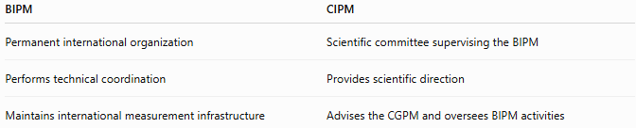
BIPM | CIPM
Permanent international organization | Scientific committee supervising the BIPM
Performs technical coordination | Provides scientific direction
Maintains international measurement infrastructure | Advises the CGPM and oversees BIPM activities

BIPM vs. National Metrology Institutes
# Source: AI Source: Provided by: [Data Path: Persons Table -> ID Column: 1, Name_En Column: Motasem Essam] -> From: [ChatGPT] on [7/17/2026]
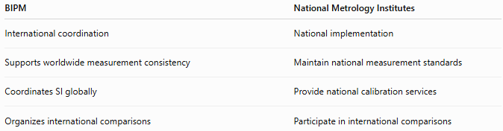
BIPM | National Metrology Institutes
International coordination | National implementation
Supports worldwide measurement consistency | Maintain national measurement standards
Coordinates SI globally | Provide national calibration services
Organizes international comparisons | Participate in international comparisons

Conclusion
# Source: AI Source: Provided by: [Data Path: Persons Table -> ID Column: 1, Name_En Column: Motasem Essam] -> From: [ChatGPT] on [7/17/2026]
The International Bureau of Weights and Measures (BIPM) is the international organization responsible for coordinating the global measurement system and ensuring the worldwide uniformity of measurements. Established in 1875 under the Metre Convention, the BIPM works with the CGPM, CIPM, and national metrology institutes to maintain the International System of Units (SI), promote measurement traceability, organize international comparisons, and support science, engineering, healthcare, manufacturing, and international trade. Its work provides the foundation for accurate, consistent, and internationally recognized measurements.

